DYPIEMR(E&TC)

# Dr. D. Y. Patil Pratishthan’s

**DR. D. Y. PATIL INSTITUTE OF ENGINEERING, MANAGEMENT & RESEARCH**

# Approved by A.I.C.T.E, New Delhi , Maharashtra State Government, Affiliated to Savitribai Phule Pune University

Sector No. 29, PCNTDA , Nigidi Pradhikaran, Akurdi, Pune 411044. Phone: 020–27654470, Fax: 020-27656566

Website : [www.dypiemr.ac.in](http://www.dypiemr.ac.in/) Email : [principal@dypiemr.ac.in](mailto:principal@dypiemr.ac.in)

**Experiment No: 4**

**Title:** To study the characteristics of the Gunn diode oscillator.

**Objectives:**

1.To study V-I Characteristics of Gunn Diode oscillator.

2.To study output power and frequency as a function of voltage.

**Apparatus:** 1. Gunn oscillator 2. Gunn power supply 3. PIN modulator 4. Isolator 5. Frequency meter 6. Variable attenuator 7. Detector mount 8. Waveguide stands 9. SWR meter, Cables, and Accessories.

**Circuit Diagram:**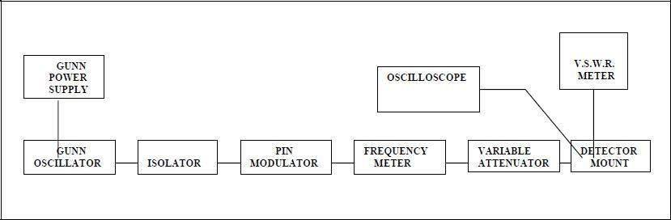

**Theory:**

Gunn diodes are negative resistance devices which are normally used as low power oscillator at microwave frequencies in transmitter and also as local oscillator in receiver front ends. J B Gunn (1963) discovered microwave oscillation in Gallium arsenide (GaAs), Indium phosphide (InP) and cadmium telluride (CdTe). These are semiconductors having a closely spaced energy valley in the conduction band as shown in Fig. 4.1(a) for GaAs. When a dc voltage is applied across the material, an electric field is established across it. At low E-field in the material, most of the electrons will be located in the lower energy central valley Γ. At higher E-field, most of the electrons will be transferred in to the high-energy satellite L and X valleys where the effective electron mass is larger and hence electron mobility is lower than that in the low energy Γ valley. Since the conductivity is directly proportional to the mobility, the conductivity and hence the current decreases with an increase in E-field or voltage in an intermediate range, beyond a threshold value Vth as shown in Fig. 4.1(b). This is called the transferred electron effect and the device is also called „Transfer Electron Device (TED) or Gunn diode‟. Thus the material behaves as negative resistance device over a range of applied voltages and can be used in microwave.

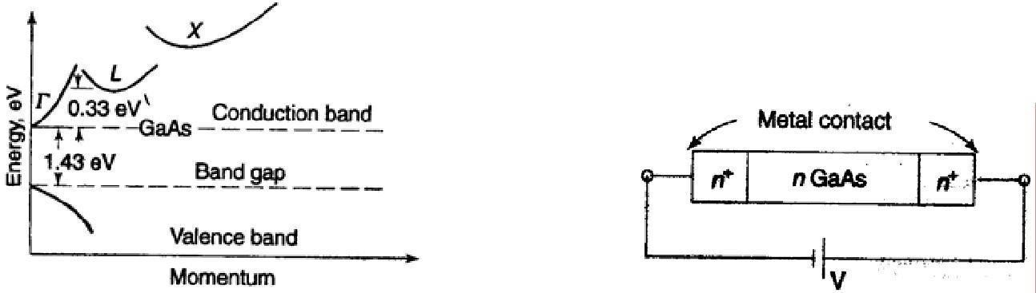

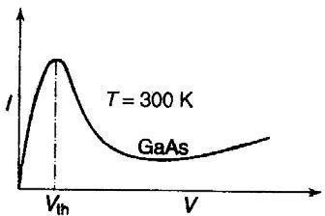**Figure 4.1(a)**

**Figure 4.1(b)**

The basic structure of a Gunn diode is shown in Fig. 4.2 (a), which is of n-type GaAs semiconductor with regions of high doping (n+). Although there is no junction this is called a diode with reference to the positive end (anode) and negative end (cathode) of the dc voltage applied across the device. If voltage or an electric field at low level is applied to the GaAs, initially the current will increase with a rise in the voltage. When the diode voltage exceeds a certain threshold value, Vth a high electric field (3.2 KV/m for GaAs) is produced across the active region and electrons are excited from their initial lower valley to the higher valley, where they become virtually immobile. If the rate at which electrons are transferred is very high, the current will decrease with increase in voltage, resulting in equivalent negative resistance effect.

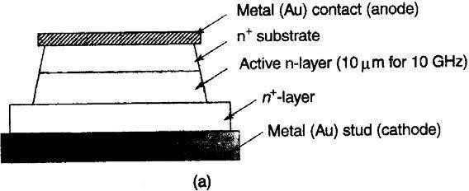

**Figure 4.2(a)**

Since GaAs is a poor conductor, considerable heat is generated in the diode. The diode will be bonded into a heat sink (Cu-stud). The electrical equivalent circuit of a Gunn diode is shown in Fig. 4.2 (b), where Cj and – Rj are the diode capacitance and resistance, respectively, Rs includes the total resistance of lead, ohmic contacts, and bulk resistance of the diode, Cp and Lp are the package capacitance and inductance, respectively. The negative resistance has a value that typically lies in the range –5 to –20 ohm.

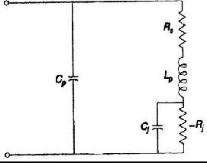

**Figure 4.2(b)**

**Gunn Oscillator:**

In a Gunn Oscillator, the Gunn Diode is placed in a resonant cavity. In this case the oscillation frequency is determined by cavity dimension than by the diode itself. Although Gun Oscillator can be amplitude-modulated with the bias voltage, we have used separate PIN modulator through PIN diode for square wave modulation.

**Procedure:**

1. First connect the Gunn test bench as shown in block diagram (a). Switch on the Gunn power supply.

2. The Gunn bias is adjusted to 9V (below 10V).

3. The micrometer of the Gunn oscillator is varied.

4. The tunable frequency meter is tuned until there is a dip in the ammeter.

5. The operating frequency can be taken in terms of GHz.

6. The Gunn oscillator micrometer reading and the corresponding frequency are shown in the frequency conversion charts.

7. Similar frequency conversion charts are provided for the frequency meter reading.

8. Note the frequency corresponding to Gunn oscillator micrometer reading and the frequency corresponding to frequency meter reading.

9.Both the frequency readings should be the same.

10. The above procedure is repeated for different values of the Gunn oscillator micrometer values.

11.For V-I characteristics of Gunn connect the test bench as block diagram.

12. Vary Gunn supply voltage from minimum (i.e. 0V to 6V), note down the Corresponding Gunn current when it is in current (I) mode. 13. Plot graph between Gunn supply voltage Vs Gunn supply current.

**Basic precautions:**

Do not keep Gunn bias knob position at threshold position for more than 10-15 seconds. Reading should be obtained as fast as possible. Otherwise, due to excessive heating, Gunn diode may burn.

# Observations:

|  |  |  |
| --- | --- | --- |
| **Sr.No.** | **Gunn supply voltage** | **Gunn supply current** |
|  |  |  |
|  |  |  |
|  |  |  |
|  |  |  |
|  |  |  |
|  |  |  |

**Sample graph:**

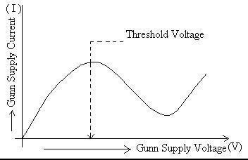

**Result:**

**Conclusion:**

**Questions:**

1. What is GUNN diode ?
2. Draw the equivalent Circuit for GUNN?
3. What are the different modes in GUNN diode oscillator?
4. How many junctions are there in GUNN?
5. Explain the transferred electron effect in GUNN?
6. What are applications of GUNN?

# References:

1.M. Kulkarni, “Microwave and Radar engineering”, 3rd edition, Umesh Publications.

2.M L Sisodia& G S Raghuvanshi, “Basic Microwave Techniques and Laboratory Manual”, New Age International (P) Limited, Publishers.